**Create Web API core project using CLI**

1. Inside the specific folder execute below command in command prompt:



After executing above command, the web api project will be created.

1. To build the application in command prompt i.e

Navigate inside to application folder and execute below command.



1. To run the application, execute below command



After running, it will show below URL where you can run in browser:

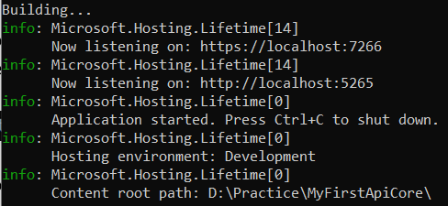

While executing the above URL and swagger like below:

<https://localhost:7266/swagger/index.html>.

Swagger:

1. Is used to test the web API like postman
2. By default it is installed in the project.